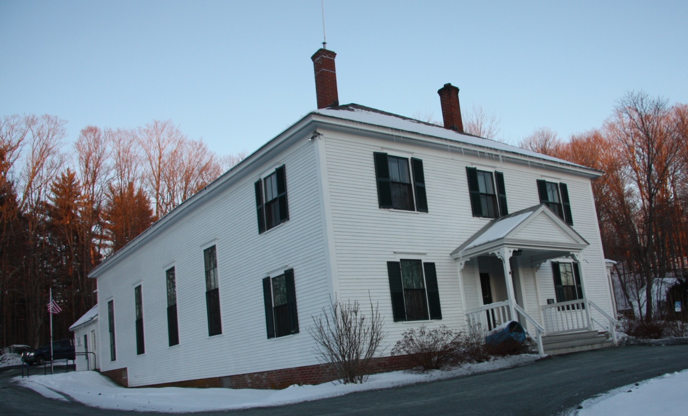
Plainfield Town Hall
110 Main St., Meriden, N.H.
Window Assessment


399 Old Stagecoach Rd.
Danville, VT 05828
(802) 684-2524
safishburn@gmail.com

This report was funded by a grant from The New England Grass Roots Environment Fund

History
The Colonial Revival Town Hall was built in 1895 and underwent major renovations in 1995. Since 1995, the Town Hall has housed the town offices in the main building block with the police department in the back. One of the Plainfield Energy Committee’s projects is to benchmark the energy usage of the municipal buildings and work towards a reduction in that usage. The Town Hall is one of the buildings that they are working on.
Towards that end they have spent time insulating and air sealing the Town Hall Building. They have done an admirable job as noted in a Preliminary Energy Assessment conducted in 2011 by Peregrine Energy Group, Inc. That assessment provided several steps for reducing the energy usage in the building including “energy-related window repairs.” The Energy Committee is currently investigating the most appropriate and sensible way to increase the energy efficiency of the windows.
Windows
There are sixteen windows in the Town Hall, eight large double-hung windows with 6 lites over 6 lites measuring 40” x 9’-6” and seven smaller two lite over two lite double-hung windows measuring 32” x 64”. In addition there is one two lite over two lite, single-hung window in the police offices, in the small addition at the back of the building. This “odd” window is most likely a salvaged window installed at a later date.
The windows have an ogee profile and include a pulley and weight counterbalance system. The double-hung windows are original to the 1895 construction. The window frames are constructed of Southern Yellow Pine and the sashes appear to be Eastern White Pine but could be constructed of Southern Yellow Pine. These windows are constructed of solid old growth wood that is very rot-resistant. They have survived well for almost a hundred and twenty years and will easily last another hundred years.
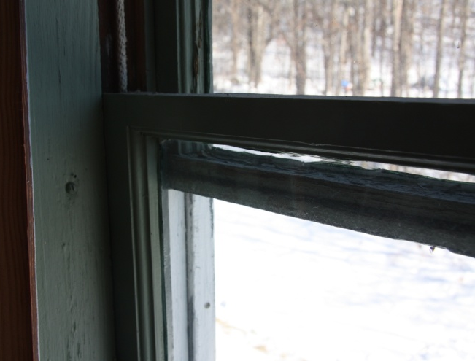
Single-hung windows differ from double-hung windows in that the top sash is fixed and creates the back of the sash channel that the bottom sash raises and lowers in. The meeting rails on single-hung windows are the same thickness as the sashes and just over-lap.
The meeting rails in the double-hung sashes are wider than the sashes and included a stepped beveled face that allows the meeting rails to inter-lock when the sashes are closed. This creates a stepped joint that limits air infiltration between the top and bottom sashes. On many of the large window units the meeting rails no longer line up because the top sash is dropped down. In the most extreme case the top sash is dropped about two inches. This allows air to flow through the gap between the meeting rails and between the top of the top sash and the frame. The dropped top sash have been painted in this position requiring them to be cut free before they can be returned to a properly closed position.
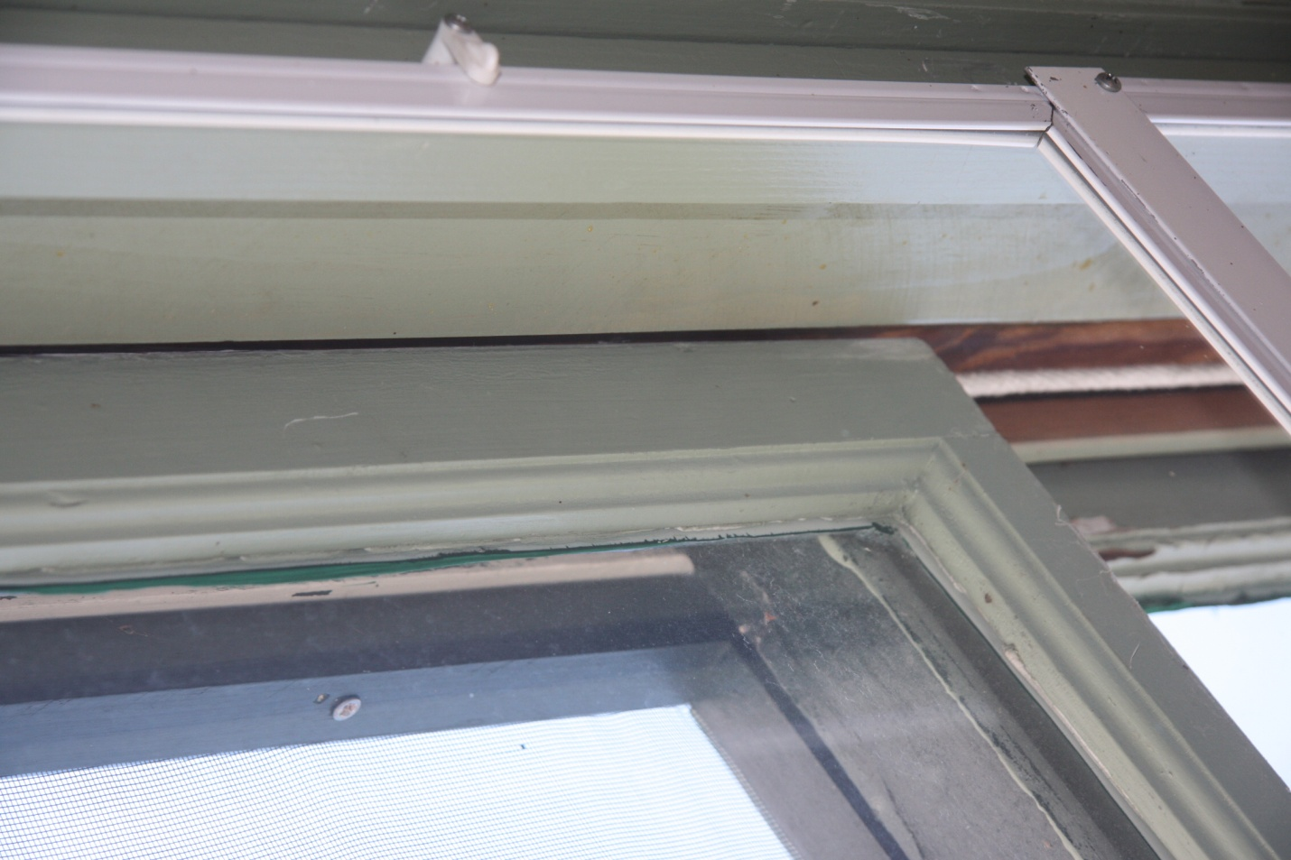
There are effective interior storm windows that are in good condition. In order to create a solid shoulder for mounting the interior storm windows a heavier piece of rectangular trim was added to the inside edge of the interior stops. This approach provides for a good seal between the storm windows and the window frames.
The sashes appear to fit squarely in the frames. In the units where the top sashes have not dropped the meeting rails line up appropriately. The windows include clearances between the sash and jambs that are a little wide but necessary for operating the windows. The addition of weather strip to the windows will stop the air infiltration that currently occurs between the sashes and the frame. With a tight primary window and a well sealed storm window a double-glazed unit is created.
In general the windows are in sound condition on the exterior but the paint finishes are failing on the interior. The exterior of the windows have all been repainted in the last 5 years. At the time any failing glazing was touched up. There are also many panes of glass that have been replaced. The glazing is sound on the exterior although the newer glazing patches are not well finessed and there is a heavy line of glazing visible on the interior. (Traditionally the exterior glazing bead is tooled so that the edge of the glazing is just narrower than the glass rabbit.)
The smaller windows on the second floor, front façade do have failing glazing. These windows appear to have received less maintenance and would benefit from full restoration at this time.
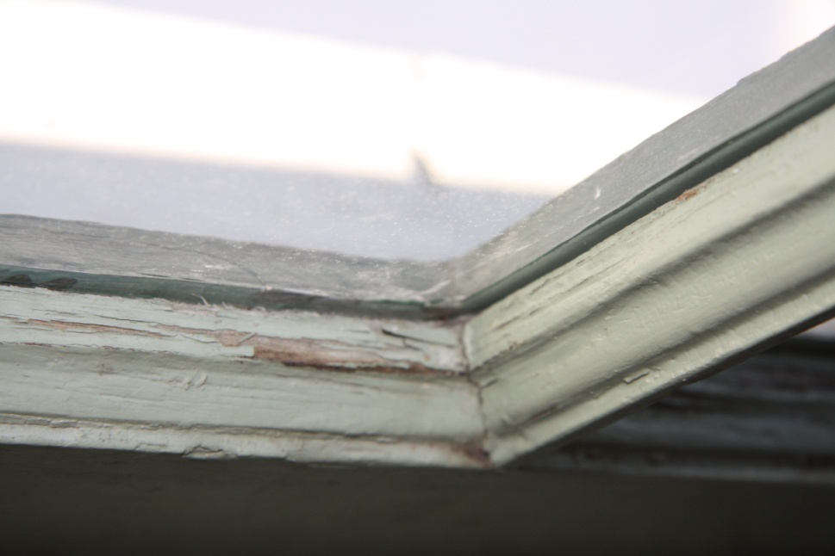
The interior paint is failing on both the sashes and in some instances on the frames. Graying wood is visible on the top surfaces of the horizontal sash parts. Gaps were also noticed in the bed glazing where the paint is failing. This is usual. These areas of the sashes receive the most weathering from the sun and condensation on the windows. It should be noted that on the day of the site visit in very cold temperatures no condensation was noted except for one upstairs window that was completely frosted.
Weight Pockets
The counter-balance weight system appears to be in good condition. All of the bottom sashes were properly roped to the weights and appear functional. Given that many of the top sashes are dropped it is assumed that either some of the ropes are broken or they are too long.
At the site visit the storm window and interior stops were removed from one window in order to assess the weight pockets. The exterior casing is the exterior cover of the weight pocket. That provides a ¾” thickness of wood between the exterior air and the interior of the weight pocket. The interior wall finishes, run behind the interior casing forming the interior cover of the weight pocket.
The weight pocket is 3 3/8” x 6 5/8” x 9’-6”. The weight pockets are 8% of the over-all window opening.
There were studies conducted in Colorado which included removing the weight system and filling the weight pockets with insulation in order to increase energy efficiency. Insulating the weight pockets will increase the energy efficiency by stopping the flow of cold air through the weight pockets. The study, “The Effects of Energy Efficiency Treatments on Historic Windows” ,was conducted by The Center for Resource Conservation in Boulder Colorado and can be found at http://conservationcenter.org/assets/EffectsEnergyonHistoricWindows.pdf
This study concluded that higher energy efficiency can be gained, up to 8% reduction in air infiltration, by putting the weights into pvc tubes and filling the weight pocket around the tubes with spray foam insulation. They do not provide any cost analysis in regards to cost of the treatment verses over all energy savings. Often the 8% heating/cooling cost savings per window is not considered enough to offset the cost of retrofitting the weight pockets.
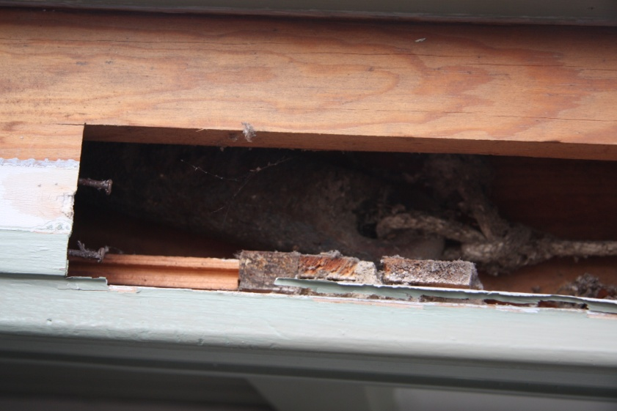
There are several issues with this pvc tube and spray foam method. One of the main tenants of historic preservation is that all work on a historic building is reversible. Spray foam insulation is not reversible. The spray foam glues together the structure that it is sprayed into. If care is not taken during the installation of the foam the window frame can be distorted by the pressure of the foam expansion creating issues with the fit and function of the window. The second issue is that if the ropes break and the weight falls to the bottom of the pvc tube there is no way to retrieve it without pulling the pvc tube out of the weight pocket. In order to install this system the casings must be removed. In this instance that would also entail cutting out the interior finishes where they bridge the space between the rough framing and the window jamb. This holds the potential for damaging the wall surfaces.
The other option that this study provides is to change the counter balance to spring balances that are installed into a groove plowed into the edge of the sashes and filling the weight pockets with insulation. These spring balances require the removal of material in the stiles that then weakens the corner joints of the windows. These historic windows are constructed with dry mortise and tenon joints that are then pinned with either wood or metal pins.
There is a third option of installing tape balances in place of the pulleys which then would allow for filling the weight pocket with insulation. In windows the size of those in the town hall the tape balance would be larger than the existing pulley in all directions. This would require cutting more of the jamb out to accommodate the tape balance and usually also involves cutting into the wall framing to accommodate the depth of the tape balance.
In some instances the top sash weights can be removed and hard board insulation installed into the exterior half of the weight pocket, providing some insulation to the weight pocket while allowing the bottom sash to function on the weights. This is a time consuming and expensive process. As with the PVC tube and spray foam method issues arise in the fact that the wall plaster extends across the weight pocket with the casing applied over it. That makes it impossible to access the weight pocket by removing the casing without cutting out the plaster.
With the interior storms in place it was not possible to check multiple windows by feel for how much air is filtering in through the weight pockets. On the window where the weight pocket was accessed there was no obvious air infiltration. On the one unit in which an insulated blind had been installed air could be felt flowing through the seam of the weight pocket cover (see the next section). Insuring that the exterior casings are sealed to the window frame and exterior sheathing will stop air infiltration into the weight pockets.
Test Window with Insulated Blind
A honey-combed insulated blind was installed on one of the large window units in order to test its effectiveness. The blind was installed for maximum energy efficiency with side tracks attached to the window frame. Adding this type of blind with the side tracks to a window can increase the windows over-all R-value on average by 4. The blind creates an extra air space and lowers the conductive loss of heat through the glass.
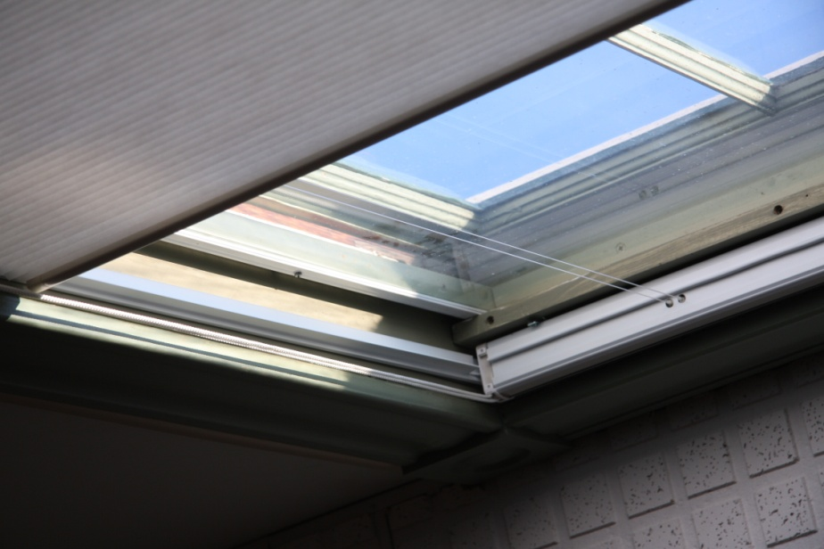
These blinds are very effective however the installation method used on this window greatly lowered the energy efficiency of the blind. The issue is that the window frame was reworked in order to still use the interior storm window and include the installation with side tracks of the blind. The interior storm windows are sized to fit to the inside of the window frame thus over-lapping the interior stops. This is an appropriate installation that blocks the flow of air between the interior stops and the jambs. However in order to move the existing interior storm window closer to the primary window (in order to create a space for the interior blind) the interior stops had to be removed. Then the interior blind was installed into the position that the storm window had originally occupied.
The interior stops provide several functions to the window structure. First they hold the bottom sash into the frame and while doing that over-lap the edge of the sash minimizing air infiltration between the sash and the jamb. They also cover the seams of the weight pocket access, stopping the flow of air through that seam. It should be noted that a sealed air space under 4” wide acts as insulation. It does not function as insulation if air can circulate through that space.
During the site visit air could be felt moving through the seam from the weight pocket cover in the space between the interior storm window and the insulated blind. This effectively negates any insulating benefit that the interior blind would provide. If there is a desire to use the insulated interior blinds then the interior storms should be removed and the blinds installed in their position maintaining the interior stops in place.
A choice would have to be made to either maintain the existing interior storm windows or install interior blinds. In order to install the blinds and have an interior storm windows, new interior storm windows would have to be installed the fit to the inside of the interior stops for the combination to be functional and effective. No matter the choice adopted for increased energy efficiency to the interior the addition of an exterior storm window would further increase the energy efficiency and protect the primary windows from the elements. When considering the storm window/blind options consideration should be given to how the windows will function with the added layers.
Storm Windows
A modern insulated glass window generally has an r-value approaching 2. A primary sash with a storm window is effectively a double-glazed window and can equal or perform a little better than a modern double-glazed window. Adding a second storm window will further increase the r-value. As noted above the addition of an insulated interior blind can add up to an r-value of 4. In all cases a poorly executed installation job will reduce the energy savings.
It is assumed that the choice was made to install interior storm windows in order to maintain the historic look of the window from the exterior. The triple track aluminum storm windows that are commonly installed on the exterior are often found to detract from the historic look of the building. There are exterior storm window options created specifically for historic buildings that have a lower profile.
These low-profile aluminum storm windows mount flush with the exterior casings. They are made from heavier aluminum extrusion and are very sound, tight storm windows. They blend in with the window making them hard to notice from the exterior. Allied Windows manufactures these low profile aluminum storm windows for use on historic buildings. They have two different models which work well for double-hung windows, the HOL-OP and the HOL-B. The HOL-OP are a two track model in which a screen is permanently mounted in the lower half and the lower storm panel raises and stores in the upper position when opening the window for ventilation. Both the bottom and top storm panels remove to the interior. The HOL-B is a single track version that requires the lower storm panel to be interchanged with the screen for ventilation. In this case storage is required for the screen or storm panel when not in use.
The addition of low-E glass to the storm window can further increase energy efficiency while minimize the damage caused by U.V. rays. The low-E glass is polarized so that it allows for solar heating in the winter but blocks solar gain in the summer reducing the heating/cooling loads on the building. Due to the fact that the low-E coating creates a greenish tint it will subtly change the exterior appearance of the windows.
Scope of Work
The concerns voiced by the Energy Committee were two fold: to increase energy efficiency and to do that in a manner that considers long-term maintenance and costs. If considering the long term to be 75 years or more the cost of restoring the historic windows and maintaining them is more cost effective than replacing replacement windows three or more times. Restoring and maintaining the existing windows also limits materials ending up in the landfill and keeps the money in the local economy.
The reality is that the windows do not warrant complete restoration at this time. Full restoration includes completely stripping all of the paint and glazing from the windows and re-glazing, painting, re-fitting to the frame and re-installation with weather stripping. There will be a time when that becomes necessary as the glazing continues to fail and as the layers of paint build up. If there is a desire to remove any lead based paints then full restoration should be pursued now.
The possibility of the windows having lead based paint is high. Although the EPA RRP regulations for working on surfaces hosting lead based paint do not apply to public buildings they should be followed while working on the windows to minimize lead dust being released into the environment and to protect those who work in the building. The contractor hired to complete the work should be knowledgeable about the regulations and willing to follow them with a common sense approach.
The minimum work required in order to increase the energy efficiency for the existing historic wooden window would be to weather strip the primary sashes. A weather stripped primary sash with a good, tight storm window equals the r-value rating of an insulated glass window.
This is a matter of re-fitting the sashes to the frames with the appropriate clearances for the weather strip and re-installing them with weather strip. In the process the top sashes should be returned to their appropriate closed position and any broken ropes replaced. If desired an exterior stop can be added under the top sashes to prevent them from dropping down in the future. While the sashes are out of the frames any heavy paint build up will be removed from the frames.
However one step better would be to include repainting of the interior of the sashes in the scope of work to protect the interior surfaces from further deterioration. Down the road further deterioration would increase the cost of full restoration. The sashes would be easier to repaint while out of the frames. All failing paint should be scraped to refusal, the painted surfaces should be washed and scuff sanded prior to repainting. Painting is a labor intensive process and the longevity of the paint job correlates directly to the prep work performed.
At the end of the report is a set of Window Restoration Specifications that S.A. Fishburn, Inc. follows for full window restoration.

For studies on historic window/storm window restoration energy efficiency please refer to
http://www.nps.gov/tps/sustainability/research.htm
and for more information on window restoration verses replacement please refer to
http://www.preservationnation.org/information-center/sustainable-communities/buildings/weatherization/windows/#.UwjmA869ZfQ

Cost Estimates
Option 1 – These prices are for refitting, re-hanging the weights and weather stripping the primary windows.
Large windows: $350/window x 8 = $2,800.00
Small windows: $225/window x 8 = $1,800.00
$4,600.00
Option 2 – Option 1 plus glazing touch up and repainting interior of the sashes and frames, does not include trim, the casings and stools
Large windows: $700/window x 8 = $5,600.00
Small windows: $400/window x 8 = $3,200.00
$8,800.00
Option 3 – Full Restoration of the windows, see specifications listed at the end of the report
Large windows: $3,066.00/window x 8 = $24,528.00
Small windows: $1,168.00/window x 8 = $ 9,344.00
$33,872.00
Weight Pockets: To add hardboard insulation to the exterior half of the weight pocket:
Large window: $250/unit
Small window: $125.00/unit
Storm Windows – for the installation of Allied HOL-OP exterior storm windows, finished in white with 1/8” glass on all 16 windows Total Cost: $13,100.00
The addition of low-E glass to the storm windows would increase the cost per window
Installing HOL-B instead of HOL-OP units would reduce the cost to: $11,500.00
Installing Harvey Tru-Channel triple track storm windows would reduce the cost to: $9,300.00
Note: These cost estimates are provisional and for planning and fund raising purposes. As in all construction related fields the costs will vary depending on the contractor hired and the specifications that they choose to follow. These prices reflect the upper end of the pricing spectrum.
Specifications for Historic Wooden Window Restoration
Sash
The sash will be removed from the frames for inspection and restoration. The sash and any other parts of the frame removed will be labeled for reinstallation in their original location. The sash will be restored off site. During the sash’s absence the window opening will be filled and secured with plywood or hardboard insulation filler until the sash is re-installed.
If the paint on the sash is failing, thick, a rough finish or tests positive for lead the paint will be stripped completely either by steam stripping or infrared heat. If any of the putty is failing the glass will be removed and re-glazed. If the exterior putty is sound but the interior bed glazing is failed the glass will be removed and re-glazed. Failing bed putty can be assessed by sight and sound; if you wrap on the glass and it rattles it is failing. If the putty is cracked and most likely over 30 years old it is beyond its serviceable life and should be removed.
The sashes will be inspected and necessary repairs made. Repairs shall consist of either epoxy consolidation or wood patches depending on the nature of the damage. In all repairs made with wood patches the wood will be the same species as the wood used in the original sash. If repair work is required at the joints, the joints will be separated, repaired, reassembled and pinned. Joints will not be glued together or repaired in any way that results in the joint being permanently fixed.
Once the sashes are repaired they will receive a coat of heated boiled linseed oil in order to recondition the wood. The glass rabbits will be primed with shellac to seal the wood where the glazing is installed. The first finish coat of paint will be applied prior to re-glazing the sash. Once the sashes are re-glazed two coats of finish paint will be applied. These coats of paint will over-lap from the wood and glazing onto the glass no more than 1/16th of an inch to create a weather tight seal. All of the paint used will be oil-based.
The sashes will be re-glazed with a raw linseed oil based glazing compound. The glass will be set into the glass rabbit on a bed of glazing compound. The glass will be held in place with appropriate glazing points. The glazing points will be set so that the bead of glazing will completely cover them. The exterior will be glazed in one continuous bead around the window. There will be no fissures or cracks in the glazing. The sashes will be painted immediately after glazing. These procedures produce a weather tight seal between the glass and the sash.
S. A. Fishburn uses organic Allback Linseed Oil Glazing and Paint. This is a no VOC paint based on traditional paint formulas. The paint will not peel but it will dull over time. Regular maintenance consisting of oiling the sash with boiled linseed oil every 5 – 10 years as the paint dulls will extend the life of the paint and glazing to 50 years.
The sash will be refit to the frames prior to re-installation. The sashes should fit so that they hang squarely in the opening with an even gap between the sashes and the window frame. The type of weather-strip used will determine the size of the gap. The meeting rails will line up and close tight when the sash lock is engaged.

Frame
Once the sash is removed the frame will be inspected and repaired as necessary. Broken or missing parting beads and stops will be replaced. The replacement parts will be milled of the same species and design as the originals.
Any extraneous pieces of wood or hardware added over the years to prop the sash in place will be removed. The sash channels will be cleaned and check for any objects that would obstruct the movement of the sash.
Where the wood is rotted or broken the failing wood will be removed to a sound surface and repaired. Repairs will consist of epoxy consolidation, wood patches, or part replacement depending on the nature and extent of the damage. Any wood patches and replacement parts will be made with wood that matches the original species used. The repairs will be primed if the original surface was painted.
Re-installation of the Sash
The sash will be re-installed in the frames and checked for proper movement. The stops will be replaced. If the screw holes in the frames are stripped out they will be filled with wood and the screws re-installed. If the upper sashes are to be fixed in place, stops will be installed in the upper sash channel, running from the meeting rail to the sill. The stops will be screwed into place to facilitate sash removal in the future.
Hardware
The hardware on the sashes will be removed and cleaned. The sash locks will be lubricated and returned to good working order. Any missing or broken sash locks will be replaced. The sash pulls will be cleaned and those missing or broken replaced. The pulleys will be lubricated with a graphite lubricant.
Where weights and pulleys are present the weight pockets will be cleaned out and all sash cords and pieces removed. The weights will be checked to assure proper placement. If sash chords or chains are missing, worn, or broken new sash cords or chains will be installed. When the lower sash is fully open and the upper sash is tightly closed, the sash weights will be suspended 1” above the bottom of the sash pockets.
Weather Stripping
Unless it will interfere with a counter-balance system, V-bronze or Spring Bronze weather-strip will be installed in the window frame. This is a V shaped piece of bronze or copper that is nailed into the window jamb with the open end of the V facing the exterior.
This weather strip is applied to side jambs to fill the space between the sash and frame with the sash in the closed position. It is also applied to the head jamb above the top sash and sill below the bottom sash. The V-bronze weather strip stops the flow of air around the sash and lowers the friction when moving the sash.
If the V-bronze weather strip will interfere with the counter-balance system then a nylon pile weather strip can be installed in grooves cut into the window stiles.
These specifications are consistent with the Secretary of the Interior’s Standards for Rehabilitation, 1990.
Sally Fishburn, Updated February, 2013

